Crimes Against Women in India
A 21-Year Data Analysis (2001–2021)
Data Source: National Crime Records Bureau (NCRB), Government of India
Tools Used: Microsoft Excel | SQL Server | Power BI

1. Problem Statement
India continues to face a serious challenge in ensuring the safety and dignity of women. Despite legislative reforms and awareness campaigns, crimes against women have shown a consistent upward trend over the past two decades. This analysis aims to identify which states are most affected, which crime types are growing fastest, and what policy interventions are most urgently needed.
The objective of this analysis is to examine 21 years of official NCRB crime data to uncover patterns, trends, and actionable insights that can support government decision-making and resource allocation.

2. Data Overview
- Source: National Crime Records Bureau (NCRB), Government of India
- Time Period: 2001 to 2021
- Coverage: All Indian States and Union Territories
- Total Records: 736 rows
- Crime Types Covered: Rape, Kidnapping & Assault, Dowry Deaths, Assault on Women, Assault on Modesty, Domestic Violence, Women Trafficking

3. Tools Used
Tool | Purpose
Microsoft Excel | Data cleaning, validation, pivot table analysis
SQL Server (SSMS) | Data querying and aggregation
Power BI | Interactive dashboard and visualization

4. Key Findings
- Domestic Violence is the most prevalent crime against women in India, accounting for 39% of all reported cases — nearly 19 lakh cases over 21 years
- Uttar Pradesh, Andhra Pradesh, West Bengal and Madhya Pradesh consistently rank as the most affected states
- Total crimes against women have more than doubled from 1.14 lakh in 2001 to over 2.7 lakh in 2021
- Kidnapping & Assault has increased nearly 5 times — from 13,681 cases in 2001 to 75,369 in 2021
- Women Trafficking has seen the most alarming growth — increasing 9 times from 114 cases in 2001 to 1,071 in 2021
- Dowry Deaths have remained largely unchanged — suggesting awareness campaigns have had some effect in this area
- Tripura showed the most dramatic deterioration — crimes increased from 403 in 2001 to 32,886 in 2021
- West Bengal, Odisha and Gujarat showed improvement in overall crime numbers over the 20-year period

5. SQL Analysis
Top 10 Most Affected States
Identifies the states with the highest cumulative crimes against women over 21 years.
sql
SELECT TOP 10 State, SUM(Total_Crimes) AS Total_Crimes
FROM Crime_against_women
GROUP BY State
ORDER BY Total_Crimes DESC;

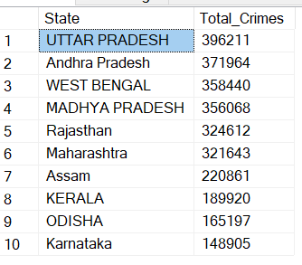

National Crime Type Summary
Calculates the total number of cases for each crime type across all states and years.
sql
SELECT
SUM(Rape) AS Total_Rape,
SUM(K_A) AS Total_Kidnapping,
SUM(DD) AS Total_Dowry_Deaths,
SUM(AoW) AS Total_Assault_Women,
SUM(AoM) AS Total_Assault_Modesty,
SUM(DV) AS Total_Domestic_Violence,
SUM(WT) AS Total_Trafficking
FROM Crime_against_women;

Year on Year Crime Trend

Shows how total crimes against women changed nationally from 2001 to 2021.

sql
SELECT Year, SUM(Total_Crimes) AS Total_Crimes
FROM Crime_against_women
GROUP BY Year
ORDER BY Year ASC;

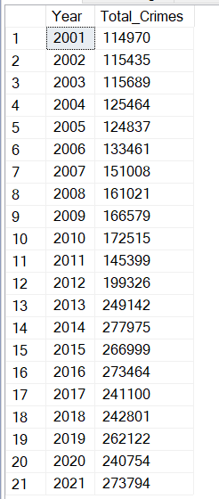

Most Improved vs Most Deteriorated States
Compares each state's crime count in 2001 vs 2021 to identify which states got better or worse over 20 years.
sql
SELECT
a.State,
a.Total_Crimes AS Crimes_2001,
b.Total_Crimes AS Crimes_2021,
(b.Total_Crimes - a.Total_Crimes) AS Change,
CASE
WHEN (b.Total_Crimes - a.Total_Crimes) > 0 THEN 'Deteriorated'
ELSE 'Improved'
END AS Status
FROM Crime_against_women a
JOIN Crime_against_women b ON a.State = b.State
WHERE a.Year = 2001 AND b.Year = 2021
ORDER BY Change DESC;

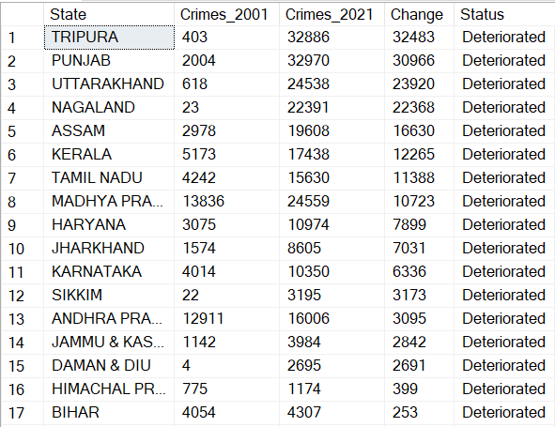
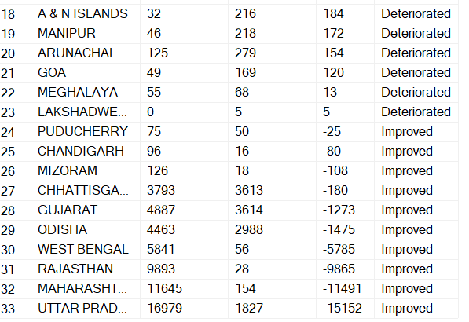

Crime Type Comparison: 2001 vs 2021
Compares each individual crime type nationally between 2001 and 2021 to identify fastest growing crimes.
SELECT
SUM(CASE WHEN Year = 2001 THEN Rape ELSE 0 END) AS Rape_2001,
SUM(CASE WHEN Year = 2021 THEN Rape ELSE 0 END) AS Rape_2021,
SUM(CASE WHEN Year = 2001 THEN K_A ELSE 0 END) AS KA_2001,
SUM(CASE WHEN Year = 2021 THEN K_A ELSE 0 END) AS KA_2021,
SUM(CASE WHEN Year = 2001 THEN DD ELSE 0 END) AS DD_2001,
SUM(CASE WHEN Year = 2021 THEN DD ELSE 0 END) AS DD_2021,
SUM(CASE WHEN Year = 2001 THEN AoW ELSE 0 END) AS AoW_2001,
SUM(CASE WHEN Year = 2021 THEN AoW ELSE 0 END) AS AoW_2021,
SUM(CASE WHEN Year = 2001 THEN DV ELSE 0 END) AS DV_2001,
SUM(CASE WHEN Year = 2021 THEN DV ELSE 0 END) AS DV_2021,
SUM(CASE WHEN Year = 2001 THEN WT ELSE 0 END) AS WT_2001,
SUM(CASE WHEN Year = 2021 THEN WT ELSE 0 END) AS WT_2021
FROM Crime_against_women;
State-wise Crime Type Breakdown
sql
SELECT State,
SUM(Rape) AS Rape,
SUM(K_A) AS Kidnapping,
SUM(DD) AS Dowry_Deaths,
SUM(AoW) AS Assault_Women,
SUM(DV) AS Domestic_Violence,
SUM(WT) AS Trafficking
FROM Crime_against_women
GROUP BY State
ORDER BY State ASC;

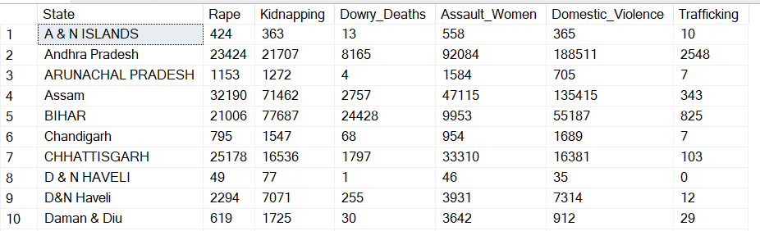

6. Dashboard Overview
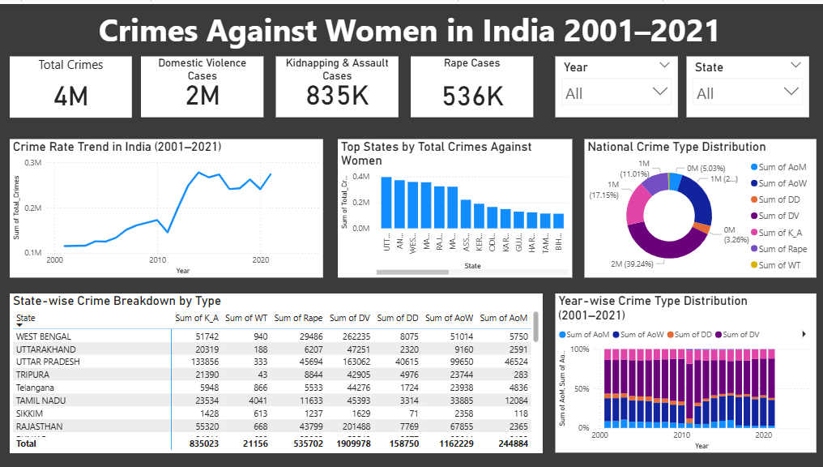
The dashboard consists of one interactive page with the following visuals:
- KPI Cards — Total Crimes, Domestic Violence, Kidnapping & Assault, Rape Cases
- Line Chart — Crime Rate Trend in India (2001–2021)
- Bar Chart — Top States by Total Crimes Against Women
- Donut Chart — National Crime Type Distribution
- Stacked Bar Chart — Year-wise Crime Type Distribution
- Matrix Table — State-wise Crime Breakdown by Type
- Slicers — Filter by Year and State

7. Recommendations
Finding | Recommendation | Addressed To
Domestic Violence accounts for 39% of all crimes | Launch dedicated DV fast-track courts and helplines in every district | Ministry of Women & Child Development
Kidnapping cases increased 5x in 20 years | Strengthen missing persons tracking system and inter-state coordination | Ministry of Home Affairs
Tripura deteriorated most drastically | Deploy special task force and conduct immediate policy review | Tripura State Government
Women Trafficking increased 9x | Increase border surveillance and rehabilitation programmes | Ministry of Home Affairs & State Police
Dowry Deaths unchanged despite campaigns | Shift focus from awareness to strict enforcement and fast-track trials | State Judiciary & Police Departments
West Bengal, Odisha, Gujarat showed improvement | Study and replicate their successful enforcement models in high-crime states | NCRB & Policy Research Bodies

8. Conclusion
This analysis of 21 years of NCRB data reveals that crimes against women in India are not only increasing in volume but also diversifying in nature. While some progress has been made in areas like Dowry Deaths, emerging crimes such as Kidnapping and Women Trafficking demand urgent policy attention.
Data-driven governance — where resources are allocated based on crime patterns rather than assumption — can significantly improve outcomes for women's safety across India. This analysis provides a foundation for such evidence-based decision-making.

